**Diploma in ICT & Computing**

**Assignment Specification**

**Institute Name :** IDM Achievers International Campus

**Unit Name :** Introduction to Web Designing & Development-Part 1

**Unit Value :** Unit - 05

**Lecturer :**

**Unit Outcomes :**

1. Demonstrate and deliver a range of transferable skills
2. Show evidence of working and contributing to a group situation
3. Identify a given problem and provide feasible solutions
4. Monitor and review own learning experience.

**Date Set : Due Date :**

**Student Name : H/O Registration No :**

**Branch Name : IDM Student No :**

**Assessor Comments:**

**Assessor Signature: Date: ___/___/___**

Create a web site for mobile phone application. Give priorities to create informational, dynamic, and simple corporate web sites such as an informational web site. You may need to consider the following requirements.

**The web site should meet following requirements:**

* It should include minimum 3 pages.
* Adobe Flash, Photoshop, Dreamweaver should assisted.
* It should be able to use as a mobile site as well.
* You can use Web Templates.
* You are free to choose a creative design which customer also satisfied.
* Chosen colors, images, and any other media clip and compatibilities will be considered on assess.
* Entire web site should have a good navigational method with hyperlinks.

**Assignment criteria**

* You should create the logo using the Photoshop.
* Display different types of mobile phones with the description.
* Allow the customer to Inquiry about selected mobile phone online etc……….

**The specification Criteria**

1. Home Page

A) Brief description of company

1. About us Page

B) Vision, Mission and Detailed Description of Company

1. Contact us Page

C) General Contact Details

**Try to design your layout considering following sample designs.**

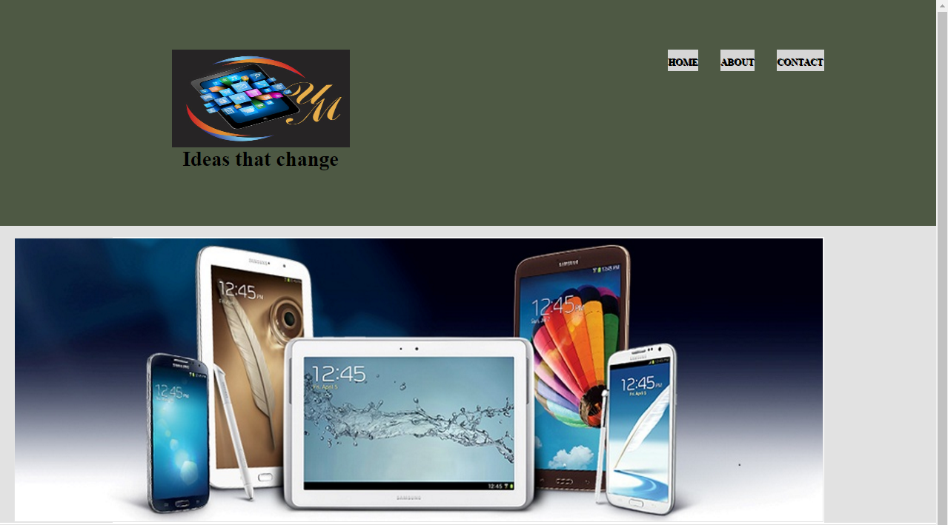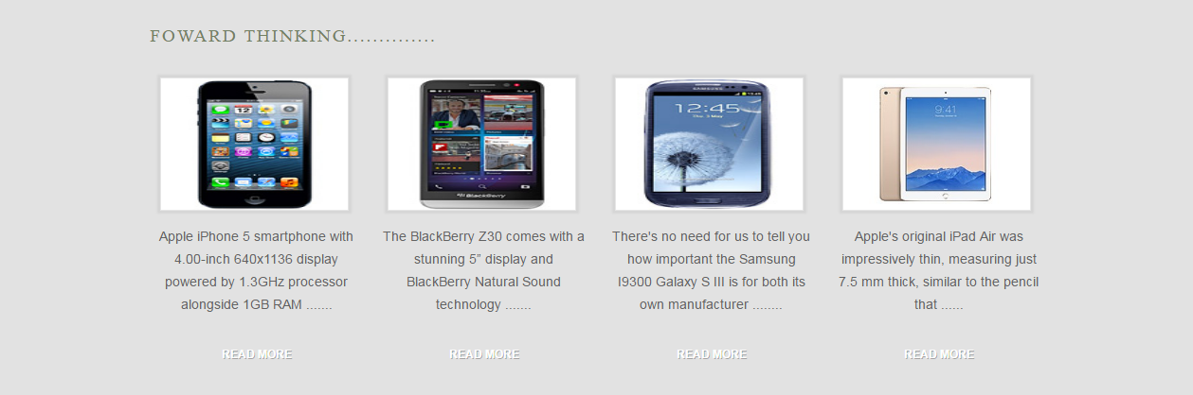

**More Description about the Phone**

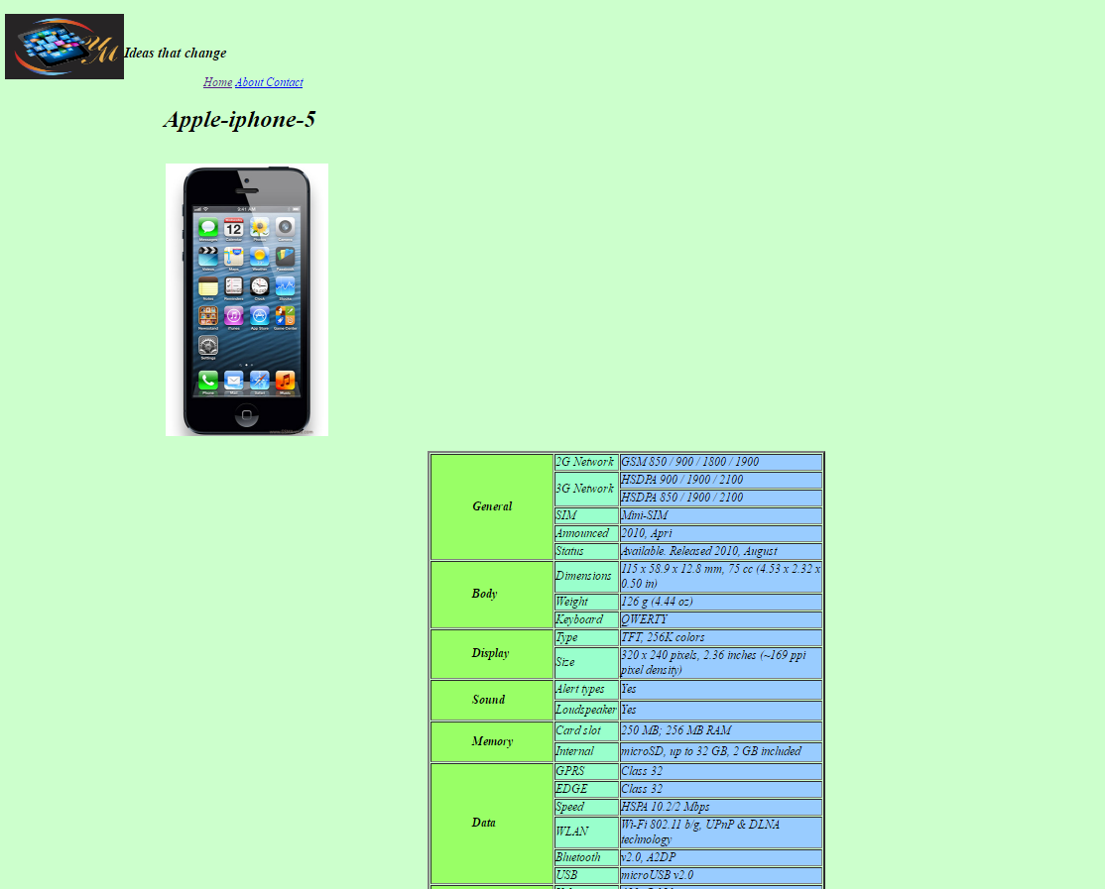

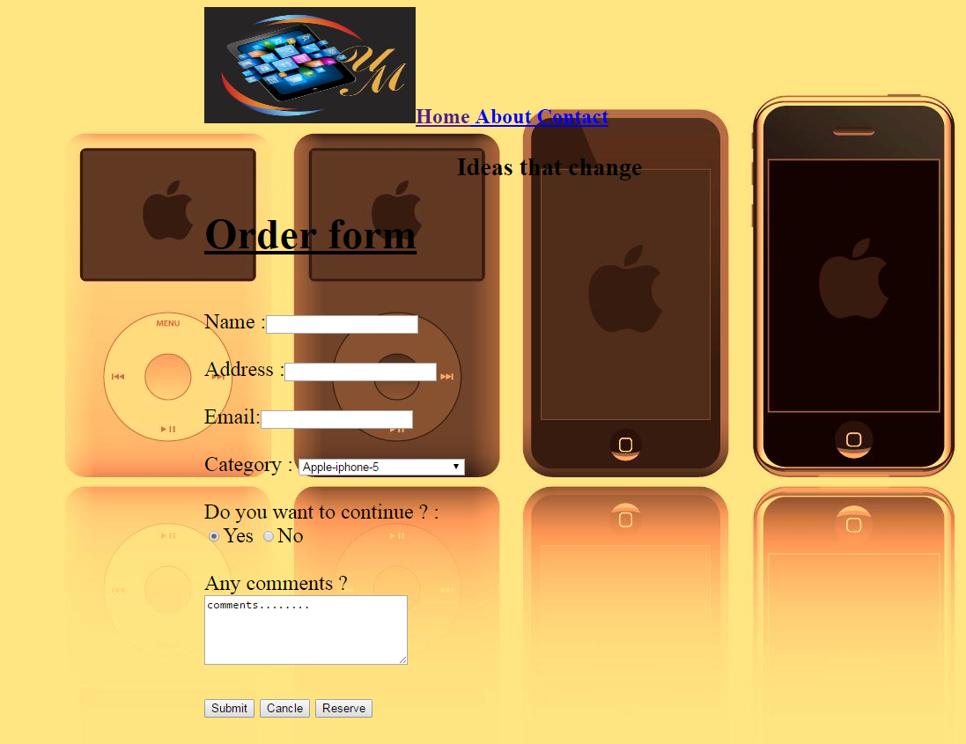**Order Form Layout**